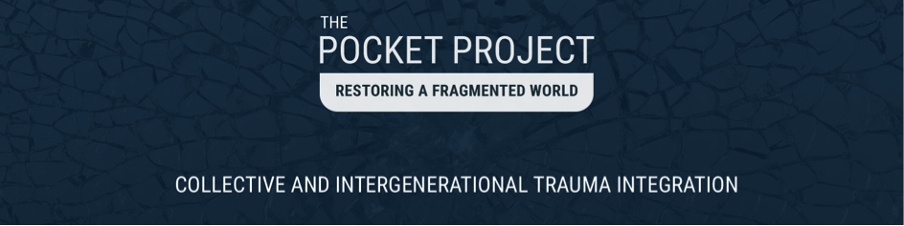

Pocket Project Training Application

Please fill in your answers to the application questions below, and attach your photo to the document. Then, upload your application via the form on the Pocket Project website: http://pocketproject.org/training/application
Or, if you have trouble using the online form to upload, you may email your application to:
info@pocketproject.org
You will be notified of our decision on your application within one week. If accepted into the program, you will be provided a link to register along with all of the details about the Israel workshop.
INSERT YOUR PHOTO HERE

Photo Requirements
Please choose a current and good quality photo that is a “headshot” (only your head in the photo). The photo must be one of these file types: .jpg, .gif, or .png
The maximum file size is 100 KB. If you need to resize or crop your photo, please go to http://www.picresize.com/.
How to Attach Your Photo
In Microsoft Word, please click in the box above and then use the Insert > Pictures command to select and insert your photo here. (see Microsoft Help article for more info)

First Name and Surname | Nationality
Email | Date of Birth
Address | Phone
School Education
Professional Degrees / Certifications
1. What is your motivation/interest in joining the Pocket Project training?

2. What has been your exposure to Thomas Hübl’s teaching and work?
3. Which of Thomas Hübl’s courses or programs have you participated in?

_____Timeless Wisdom Training
_____Core Group
_____Assistant Group
_____Mystical Principles 1, 2, or 3
_____Mystical Principles of Healing
_____Mystical Principles of Relationships
_____Transparent Communication
_____New Year’s Retreat
_____Celebrate Life Festival

4. What is your professional background?

5. What is your experience/training in working with trauma?

6. If you are not working in a therapy/healing capacity what contact and involvement have you had with collective trauma?

7. What limitations or challenges do you have in working with people, and specifically in the area of trauma work?

8. What is your experience/training in consciousness work? (i.e. meditation practice, contemplation practice, spiritual path etc.)

9. What areas of collective trauma/healing are you interested in working in and/or researching?

10a. Are there specific regions/peoples/orientation that you are interested in?

10b. Are there specific aspects of trauma work/ healing (i.e. individuals, groups, large groups,
certain modalities) that you are interested in?

11. What do you foresee yourself doing in the field of collective trauma work in the future? What visions, project ideas, goals etc. do you see for yourself and the project in the future?

12. What personal work have you done on your own trauma/life issues (i.e. psychotherapy, healing work, spiritual work/practices etc.)?

13. How has your own personal healing work impacted/transformed your life?

14. If you are working in the field of trauma what has most influenced your work and development (i.e teachers, trainings, modalities, experiences etc.)?

15. What is your interest in learning and working with a spiritual teacher in relation to collective trauma and healing work?

16. What experience have you had working with large groups and facilitating large group processes?

17. What would you like to contribute from your own experience/work to this project?

